23.64: a) From Example 23.12:

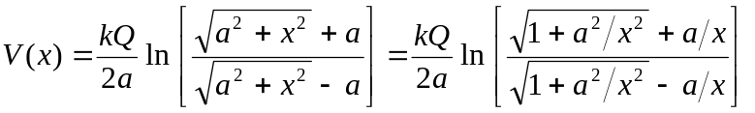
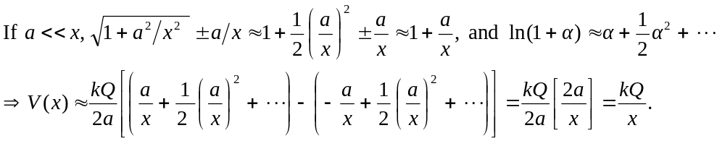
That is, the finite rod acts like a point charge when you are a long way from it.
b) From Example 23.12:
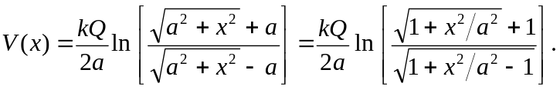
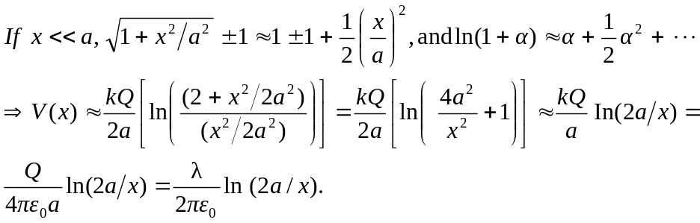
Thus 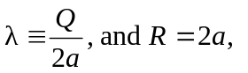which is the only natural length in the problem.

